**Proposal on**

**Mobile Management System**

`

**Softwarica College of IT & E-Commerce**

Name: Ritesh Shrestha

Student ID:170183

NCC ID:00172893

Batch No.: 21 ‘A’

Email: riteshsht@gmail.com

# Introduction

Mobile Management System is an application which allows the company to manage customer data, inventory data and computerized billing system. This application is designed especially for desktop system. This software guides the user in a simple way without any depth knowledge on computer system which is easy to operate user interface and it is complete package for small organization where users can track report on sales and inventory. Mobile company usually have different models of mobile and accessories, to keep the track of this record is very time consuming and tedious work. Primarily all inventory and billing were achieved manually that arises human calculation mistake, duplicate data. So, making systematized software application with basic requirement is vital.

This software developed using advanced language php (laravel), database with SQL. It can be pillar for an organization to manage customer data, keep inventory of company products and purchase information.

**Background**

According to our recent markets, merchants and wholesale outlets must swiftly adapt to the constantly changing technology to reduce overhead, lower cost of operation, and help to stay competitive. Everybody needs software, which can facilitate store operations and make their day-to-day lives much easier.

Mobile Store Management System is application software aimed to take benefit of today’s technology and cut or avoid the burden of storing data on paper and files.

Problem Statement

**Some key features are**:

First of all, the concept of this application is to present a form of menu which holds numerous choices for the different department like sales, administration, finance. This is the initial form so all further forms are linked with each other.

* User login and Admin login
* Add, remove or edit customer information.
* Add or update product detail or overall information.
* Manage the information of Mobile and customer.

**Project Scope**

**Scope and Limitation of Project**

This project may be applied in a small business. Corporation may not be profound on paying tons of money on records. Although these project will significantly reduce the costs. Records are directly stored in the database so no need of books or accounts.

Due to different time constrain and requirements, this System has some **limitation**. End user must have basic knowledge of computer. System can enter only one product information at a time. The search option only supports search using ID number. The user must get ID number of customer to search inside the system.

## Aims and Objectives

The main **aim** is to help the user to achieve the user interface to navigate to the details of the sales, services, stocks and customer’s. Mobile Management System is application software designed to take advantage of new technology and avoid the burden of storing data on paper and in files.

Some **objectives** are listed as follows:

1. To minimize carrying cost of inventory.
2. To keep investment in inventory at optimum level.
3. To reduce the losses of theft & wastage etc.
4. To make arrangement for sale of slow moving items.
5. To minimize inventory re-ordering costs.

1. **System Implementation**

* Computer will be used to maintain the records of the mobile, customers, sales and purchase in the computer database.
* A computerized report in a particular format can be generated.
* Mobile available can be examined.
* Easier to find the detail of overall information.

1. **Waterfall model**

Waterfall concept is a developer of the software development life cycle. Each phase of this concept is unique and well organized and the output of one phase is input of next phase. So, I decided to choose this concept.

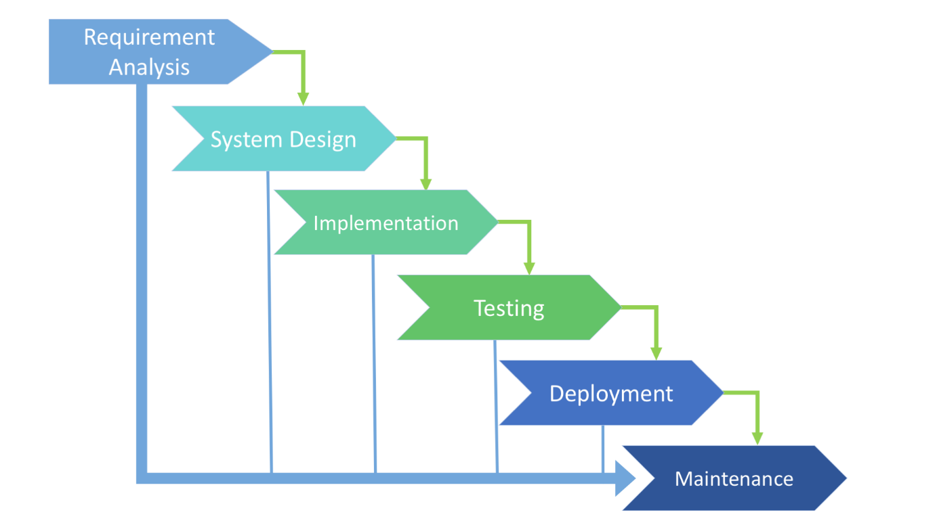

Figure 1: Waterfall Approach

### **Planning and requirement analysis**

Analysis helps the investor to discuss about the system requirement to get the final creation. The main objective is to ensure the system requirement.

### **Designing project architecture**

Next phase of the SDLC, the programmer designs the architecture. Technical questions that may seem on this phase are debated by all the investors as well as customer. The project team load, limitations, time period, and costing are discussed.

### **Development and coding**

This is the actual phase or one of the most important part of the project. Source code are created by the programmer and ensure to meet the given requirement.  
Four stages of programming.

* Algorithm development
* Source code writing
* Compilation
* Testing and debugging

### **Testing**

In this phase debugging process is implemented. The mistake and code flaws are detected and passed to the programmer. This process is done until all the critical problems are detached and software is at the stable condition.

### **Deployment**

In this stage software is finally launched to the end user. Technical support helps to the end user by providing with feedback, supports. Moreover, to make sure, that the software is up-to-date and is invulnerable to a security breach.

**Design Pattern**

In 1994 Eric Gamma introduced design pattern, it is a software design which intends to solve the problem with the best solution. It is a pattern for how to solve a problem that can be used in many different conditions.

There are lots of pattern like creational, behavior, Factory, Repository, MVC etc. Among them I like to use MVC pattern which is Model View Controller. I choose this pattern because It is simple and best way to separate the logic of this application. The key features of this pattern are:

* The view interacts with the user
* User input are handled by the controller
* Updates and Information are received to the model
* State of Model is checked by the view and respond It accordingly
* View waits another interaction.

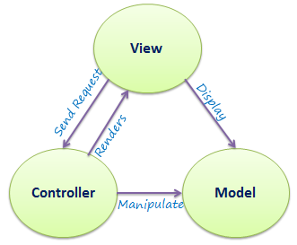

MVC had indeed moral philosophy. Code arrangement and design are simpler, Establishing the software maintainable. The view is in the view files, the logic in the template, and the controller handles them all.

**System Architecture**

System architecture is the art of design which consist of different architecture tier like N-tier, Two-tier, and three-tier. So I have chosen to use 3-tier architecture.

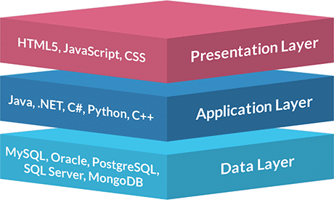

The above figure shows 3-tier architecture between user, server and database.

**Presentation layer**

Presentation layer is used to communicate with system application and end user. It is one of the topmost level application. It shows data connected to such services as browsing products, buying, and shopping cart content.

**Application layer**

One of the important tier of architecture is application layer which is responsible for the logical process. It communicates with application and database. It is independent from presentation and the database tier. It provides data to the presentation layer and also responsible for database management.

**Data layer**

This layer delivers contact to the database and manages a link to the database. The Mobile Management System is using SQL server to store the data.

## Work Breakdown Structure (WBS)

Work breakdown structure is an ordered tree structure that summaries the project. In this structure it breaks into small portion which make the complex project to simpler.

Following are the reason to use WPS:

* Precise and clear project.
* Gives exact mission and tasks to the group.
* Shows the project milestones.
* Helps to find time, cost and risk.

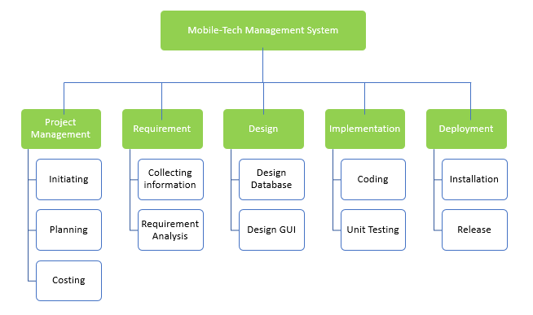

**Milestone**

A milestone represents a success, it is an aspects of project development, because project milestones are the noticeable indicators of project development near its purposes. Milestones also shows when expenditures are sent to merchants and suppliers.

The benefits of milestone are shown below

* **Observe project development**
* **Remember key dates**
* **Project identify**
* **Maintain assumption and risks**

|  |  |
| --- | --- |
| **Milestones** | **Date(MM/DD/YY)** |
| **Project Management**  Risk Management  WBS  Configuration Management  Proposal Submission | **12/21/18-1/3/19**  12/21/18-12/24/18  12/25/18-12/26/18  12/27/18-12/31/18  12/1/18-1/3/19 |
| **Analysis**  Requirement  Use Case  Architecture (Initial Class Diagram)  Analysis specification | **1/4/19-1/28/19**  1/4/19-1/8/19  1/9/19-1/13/19  1/14/19-1/20/19  1/21/19-1/28/19 |
| **Design**  Structural Model  Behavioral Model  UI Design  Database Design | **1/29/19-2/27/19**  1/29/19-2/5/19  2/6/19-2/12/19  2/13/19-2/19/19  2/20/19-2/27/19 |
| **Implementation**  Building Database  Coding | **2/28/19-3/31/19**  2/28/19-3/10/19  3/11/19-3/31/19 |
| **Testing**  Unit Testing  Integration Testing  Blackbox Testing  Whitebox Testing | **4/1/19-4/10/19**  4/1/19-4/2/19  4/3/19-4/5/19  4/6/19-4/7/19  4/8/19-4/10/19 |
| **Deployment**  User Training  Final Report | **4/11/19-4/20/19**  4/11/19-4/16/19  4/17/19-4/20/19 |

**Scheduling**

The total time estimated for this project is 121 days. Each task is separated with different time frame which is needed to complete the task.

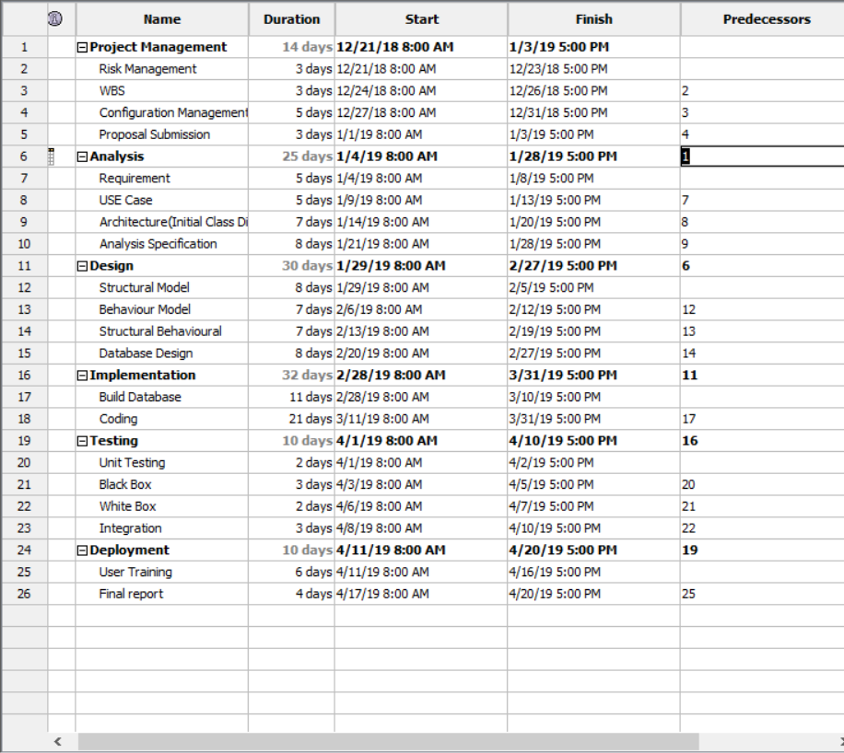

**Gant Chart**

Below figure is overall project schedule.

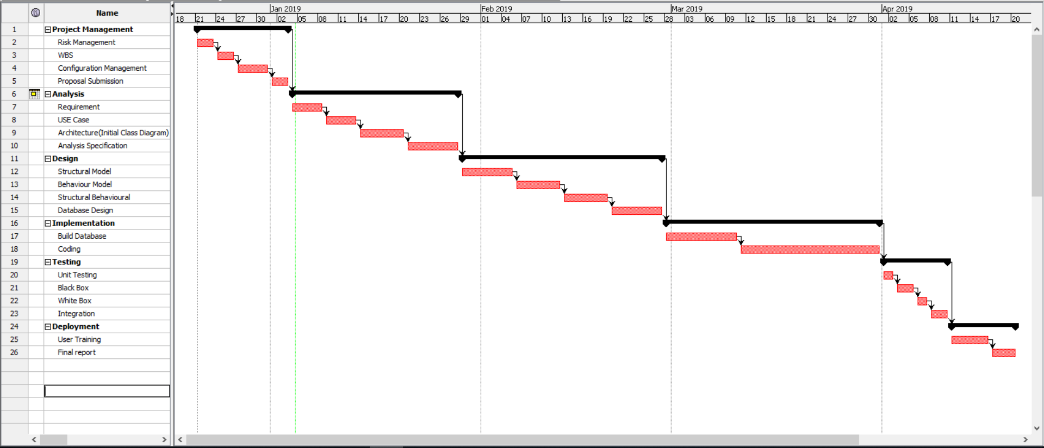

**Risk Management**

Risk management is used to manage loss which can be anything like cost increase while developing, poor software quality, extending time period. Its main features are:

* Risk Identify
* Cut the impact of risk
* Monitor risk

|  |  |
| --- | --- |
| **Likelihood** | **Value** |
| Low | 1 |
| Medium | 2 |
| High | 3 |

Table 1: Likelihood

|  |  |
| --- | --- |
| **Consequences** | **Value** |
| Very low | 1 |
| Low | 2 |
| Medium | 3 |
| High | 4 |
| Very high | 5 |

Table 2: Consequences

|  |  |  |  |  |
| --- | --- | --- | --- | --- |
| **Risks** | **Likelihood** | **Consequence** | **Impact** | **Actions** |
| Failed system | 1 | 4 | 4 | Maintain proper back up |
| Requirement alteration | 3 | 4 | 12 | Need to give proper contract. |
| Hacking | 2 | 2 | 4 | Proper security should be implemented. |
| Improbable budget | 2 | 4 | 8 | Estimate proper plan and budget |
| Virus and spam | 1 | 2 | 2 | Trusted antivirus should be install and should block unauthorized access. |
| Natural disaster | 5 | 4 | 5 | Keep backup also use cloud back up. |
| Quit job | 2 | 3 | 6 | Need of proper contract to the staff. |

Table 3:Risk Management

**Configuration Management**

Software management is a discipline containing of procedures and methods often used by administrations to manage the changes presented to its software products.

Main aims to control changes introduced to complex software systems through dependable version selection and version control.

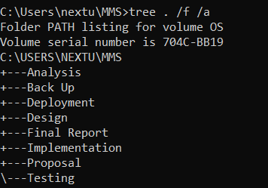

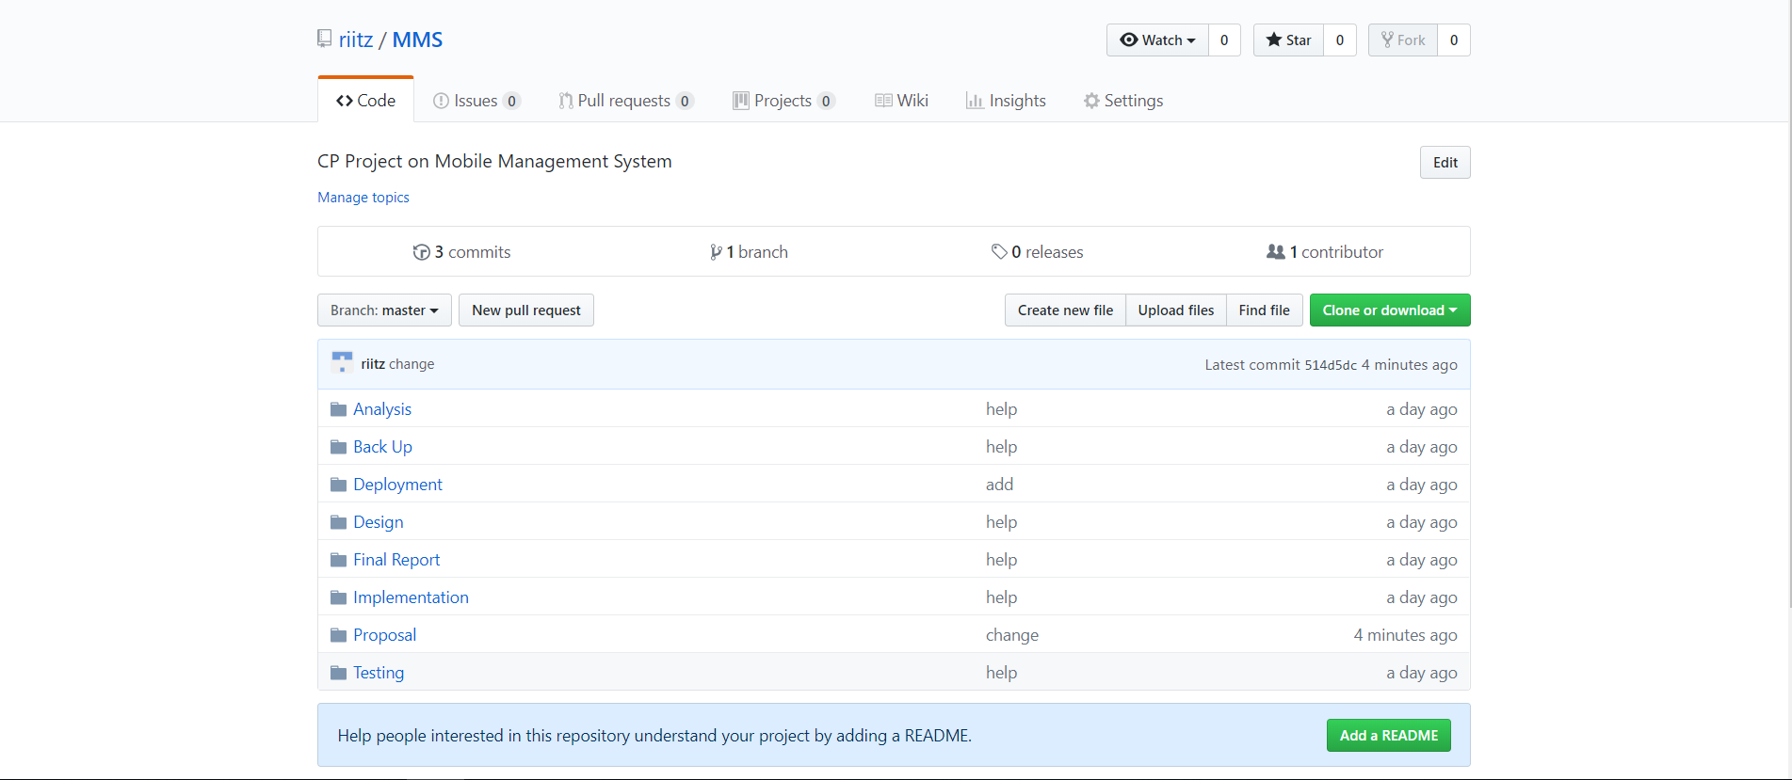

1. **Conclusion**

This system will extend the development of control. I hope that Mobile Store Management System fulfills all basic requirements with intention of transferring to computerized billing and inventory system**.**

1. **Reference**

* Tutorials Point (2017) **SDLC - Waterfall Model** [online]   
  Available from: <http://www.tutorialspoint.com/sdlc/sdlc_waterfall_model.htm>

[Accessed on: 16 may 2018]